$$Statistics Part-2$$

$$Statistics part-1: EDA$$

$$Statistics part-2:$$

$$1) Sampling$$

$$2) Central limit theorem$$

$$3) Point estimates$$

$$4) Interval estimates$$

$$5) Confidenace intervals$$

$$6) Hypothesis testing$$

$$7) Z-table understanding$$

$$we have two types of statistics$$

$Descriptive statistics:$

$$we will work on population mean (total data analysis)$$

$Inferential statistics:$

$$we will find the sample mean and estimate the population mean$$

$$Generally we wil work on inferential statistics only$$

$$Staistic vs Parameter$$

$$statistic represents about sample$$

$$parameter represnts about population$$

$$we are finding sample mean and estimate the population mean$$

$$so here sample mean:statistic$$

$$population mean :Parameter$$

$$we are finding sample variance and estimate the population variance$$

$$so here sample variance:statistic$$

$$population variance :Parameter$$

$$we are finding sample std and estimate the population std$$

$$so here sample std:statistic$$

$$population std :Parameter$$

$$Goal: We will find the statistic and estimate the parameter$$

$$statistic might be any thing i.e$$

$$mean, median, mode, var and std$$

$$How to Choose samples$$

$Simple random sampling:$

$we will select the observation randomly$

$every observation has equal chance$

$Systematic random sampling:$

$we will alot number to each observation$

$will select the observations based on intervals$

$Stratified random sampling$

$we divide the observations into some groups$

$it might be age group$

$It might be gender group$

$It might be based on specific charcteristics$

$The groups called as strata$

$Cluster random sampling$

$$we will select the observations based on area or geographical$$

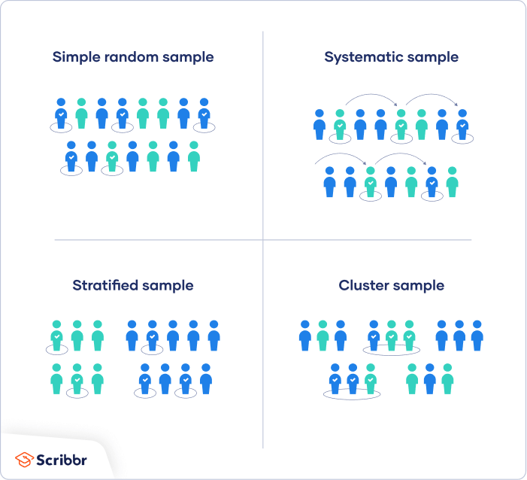

$$Central Limit Theorem$$

$Assume that we have a data of 1500 observations$

$if this data does not follow normal distribution$

$we are dividing this data into S=50 samples$

$each sample size has n=30 observations$

$s_{1}=\left[x_{1},x_{2},….x_{30}\right] s_{2}=\left[x_{31},x_{32}…x_{60}\right] (generally will pick ramdom observations)$

$s_{1},s_{2},…. s_{50}$

$we are calculating mean of each sample : {\overline{S}}_{1},{\overline{S}}_{2},{\overline{S}}_{3},…{\overline{S}}_{50}$

$if you draw the distribution using all these 50 sample means$

$each sample mean is a single value$

$like that we have 50 values$

$now we are interested to draw a distribution on these 50 values$

$the distribution will follow normality$

$Central limit Theorem$

$$Each sample size should have minimum 30 observations$$

$$Rule-1:If originally data(population data) follows normal distributions$$

$the sample means also follows normality$

$$Rule-2:If originally data does not follows normal distribution$$

$You need to divide the data into parts each part should have minimum 30 observaitons$

$$Rule-3: More groups=== >More sample means=== >$$

$$Normality chance will increase$$

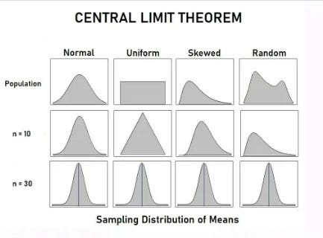

$Note: In statistics parts-1:$

$$We talked abour Raw data,$$

$$x_{1},x_{2},x_{3},….x_{n}$$

$$In statistics parts-2:$$

$$We will discuss about sample means,$$

$${\overline{S}}_{1},{\overline{S}}_{2},{\overline{S}}_{3},…{\overline{S}}_{n}$$

$$Q-1:already transformation methods are coverting into normality$$

$$then why we are doing CLT$$

$$Ans:Transformation methods on Raw data \left( statistics-1\right)$$

$$Now we will work only sample means :CLT$$

$$Mean and standard deviation of CLT:$$

$$We already know that for raw observations \left(x_{1},x_{2},…x_{n}\right)$$

$$Population mean={(x}_{1}+x_{2}+…x_{n})/n=μ$$

$$standard deviatin= σ$$

$$Population means: Mean of {sample maens(\overline{S}}_{1},{\overline{S}}_{2},{\overline{S}}_{3},…{\overline{S}}_{n})$$

$$Take 12 observations:1,2,3,4,5,6,7,8,9,10,11,12$$

$$Divide into 3 parts:\left[1,2,3,4\right],\left[5,6,7,8\right],[9,10,11,12]$$

$$Calculate each part mean: {\overline{S}}_{1}=\frac{1+2+3+4}{4}$$

$${\overline{S}}_{2}=\frac{5+6+7+8}{4}$$

$${\overline{S}}_{3}=\frac{9+10+11+12}{4}$$

$$Find the Population mean of all 12 observations={(x}_{1}+x_{2}+…x_{12})/12=$$

$$Find the population mean of 3 sample means {=\overline{(S}}_{1}+{\overline{S}}_{2}+{\overline{S}}_{3})/3$$

$$\frac{1}{3}*\left[\frac{1+2+3+4}{4}+\frac{5+6+7+8}{4}+\frac{9+10+11+12}{4}\right]= \frac{1+2+3+4+..+12}{12}$$

$$Population means:$$

$$Mean of {sample means(\overline{S}}_{1},{\overline{S}}_{2},{\overline{S}}_{3},…{\overline{S}}_{n}):μ$$

$$Mean of Means$$

$$Standard error \left( SE\right):$$

$In statistics part1 for Raw observations we called standard deviation \left(sd\right): σ$

$In statistics part2 for sample means as new observations$

$how a sample mean is deviated from population mean$

$both are not equal means some error is there$

$$we called standard error \left(se\right):\frac{σ}{\sqrt{n} }$$

$$where n=number of raw observations in a single sample size$$

$$Standard deviation definition:vs Standard Error defination$$

how much data deviating from mean

Hyderbad ========= BLR distance measured in KM

X1 ========== $μ distance meased in std \left(σ\right):$

$$How much a raw observation is deviating from population mean$$

${\overline{S}}_{1}$ ========== $μ distance meased in SE \left(\frac{σ}{\sqrt{n} }\right):$

$$How much a sample mean is deviating from population mean$$

$$Z-score:$$

$Old: \frac{x-μ}{σ}$

$$new: \frac{{\overline{x}}_{}-μ}{\frac{σ}{\sqrt{n} }}$$

|  |  |  |
| --- | --- | --- |
|  | $$Raw observations:x_{1},x_{2}$$ | $$Sample data means :s_{1}^{-},s_{2}^{-}$$ |
| $$Mean$$ | $$μ$$ | $$μ$$ |
| $$Deviation$$ | $Standard deviation :σ$ | $Standard error : \frac{σ}{\sqrt{n}}$ |
| $$z-score$$ | $$\frac{x-u}{σ}$$ | $$\frac{\overline{s}-u}{\frac{σ}{\sqrt{n}}}$$ |